Transcript: Wildfire Smoke

# 1.1 Wildfire smoke

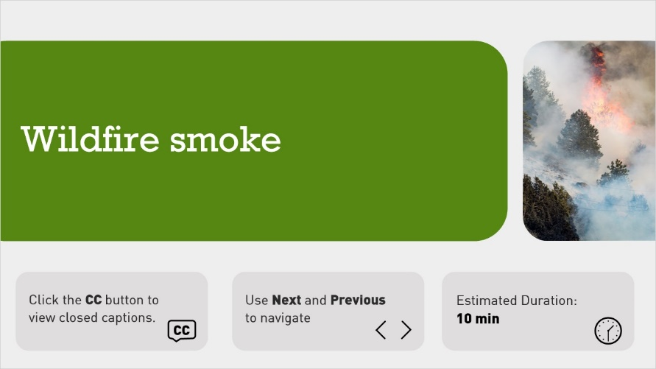

**Notes:**

Click the CC Buttons to view closed captions.

Use Next and Previous to navigate.

Estimated duration: 10 min

# 1.2 Introduction

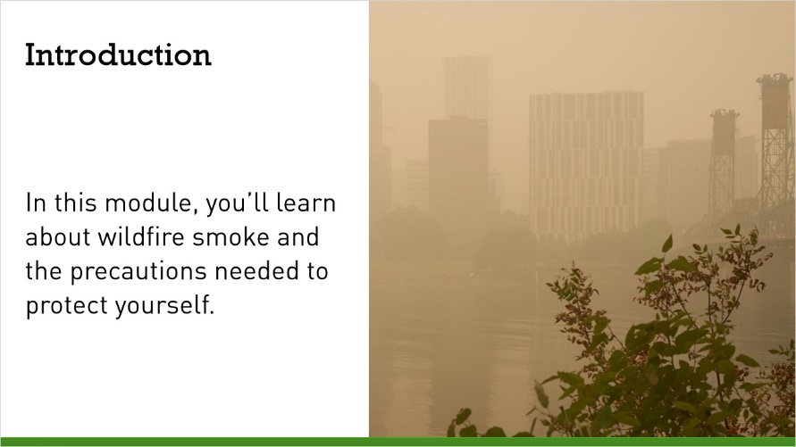

**Notes:**

In some parts of Oregon, wildfire smoke is an annual occurrence. In recent years, more and more of Oregon is vulnerable to wildfire. The smoke generated by wildfires impacts employee health and safety.   
In this module, you’ll learn about wildfire smoke and the precautions needed to protect yourself from dangerous levels of smoke. Click next when you’re ready to get started

# 1.3 How is air quality measured?

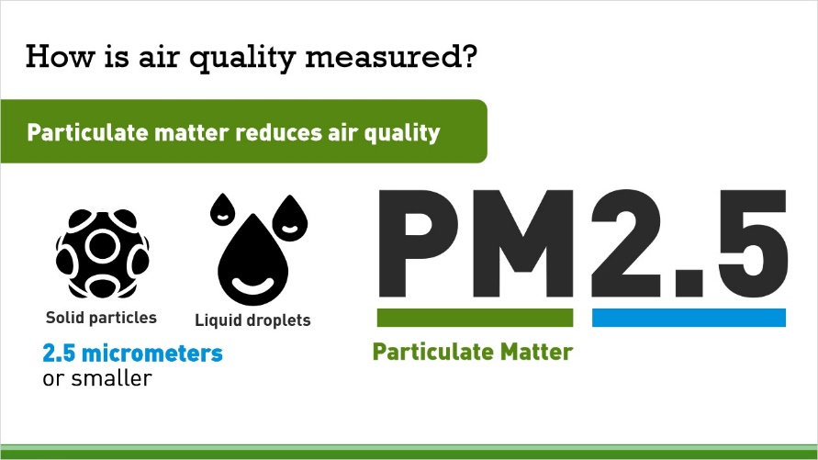

**Notes:**

The concentration of particulate matter in the air reduces air quality. Particulate matter comes in the form of solid particles and liquid droplets found in the air. Fine inhalable particles are those that are 2.5 micrometers and smaller. Smoke particles fall under this category. PM2.5 is the measurement standard used by Oregon OSHA to measure the concentration of these particles in the air.

# 1.4 What is the Air Quality Index (AQI)?

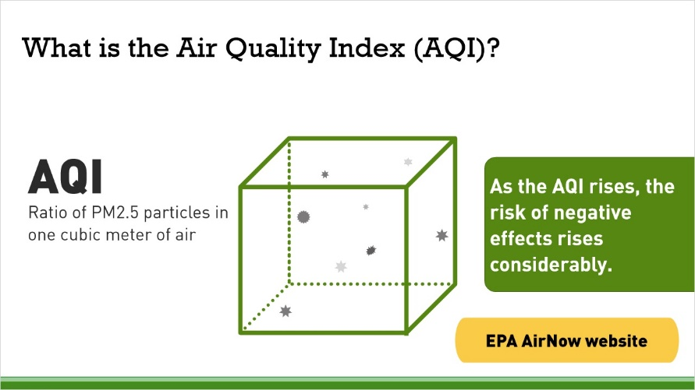

**Notes:**

Oregon OSHA uses PM2.5 to calculate the Air Quality Index. The Air Quality Index represents a ratio of PM2.5 particles present in a cubic meter of air. When it comes to AQI, lower is better. An AQI under 50 means that the air quality is satisfactory and air pollution poses little or no risk, according to the EPA.   
As the AQI rises, the risk of negative effects rises considerably. When the AQI reaches 101 and above, some people may experience adverse health effects. This is when the OR OSHA rule goes into effect.

You can learn more about the Air Quality Index at the EPA’s Air Now website. [Link]

# 1.5 Daily AQI color chart

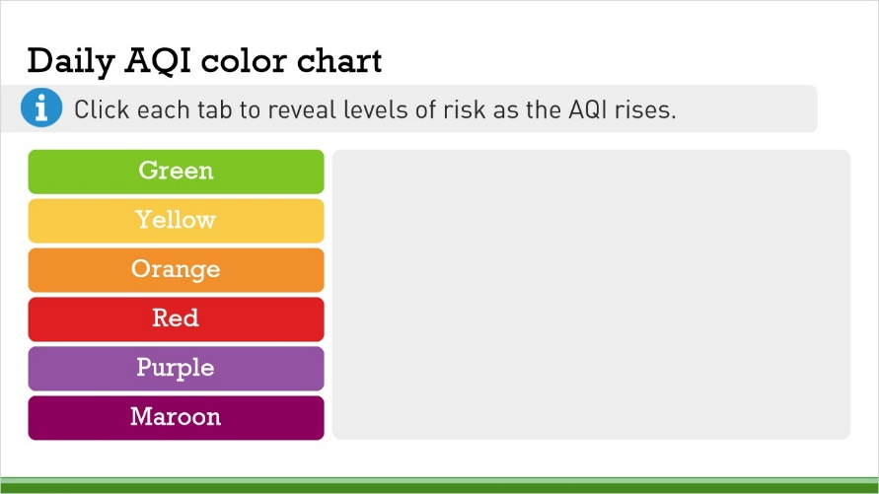

**Notes:**

This chart provides additional details about levels of risk. Click each tab to read more about levels of risk as the AQI rises.

# 1.6 How can I check the quality of the air?

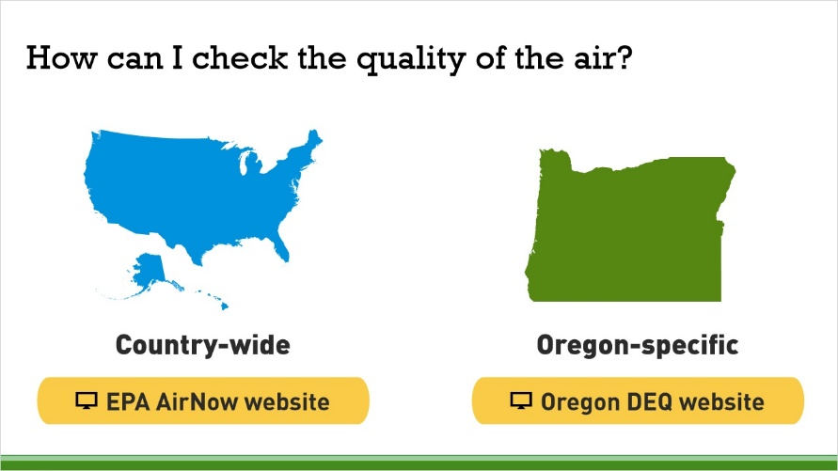

**Notes:**

The AirNow website through the EPA provides air quality index information for the entire country.   
The Oregon DEQ and OregonAir app provide air quality data specific to Oregon. Click the buttons to access these tools and bookmark them now. The OregonAir app can be found in your smartphone’s app store.   
<https://gispub.epa.gov/airnow/>   
<https://oraqi.deq.state.or.us/home/map>

# 1.7 Are there exceptions to the rule?

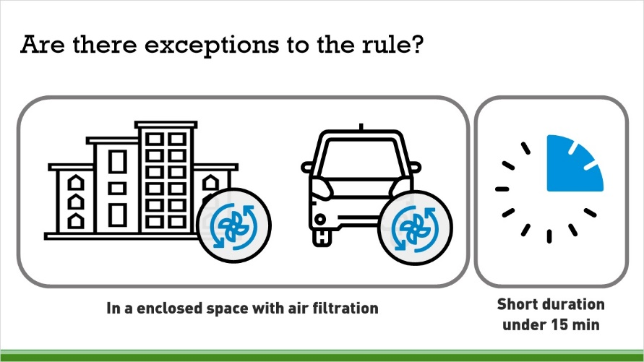

**Notes:**

If you are in an enclosed building where the air is filtered by mechanical ventilation, the rules do not apply. In this situation, however, the windows, doors, bays, and other exterior openings must remain closed, except when necessary to enter or exit the building.   
The rule does not apply if you are in an enclosed vehicle where the air is filtered by a cabin air filter. The windows, doors, and other openings must remain closed except to enter or exit the vehicle. Please note: buses, light rail, and other vehicles used for transit are not exempt from these rules.   
Another exception can occur for intermittent exposure of less than 15 minutes in any hour, or a short-duration exposure of less than two hours in a single 24-hour period.

# 1.8 What are the symptoms of smoke exposure?

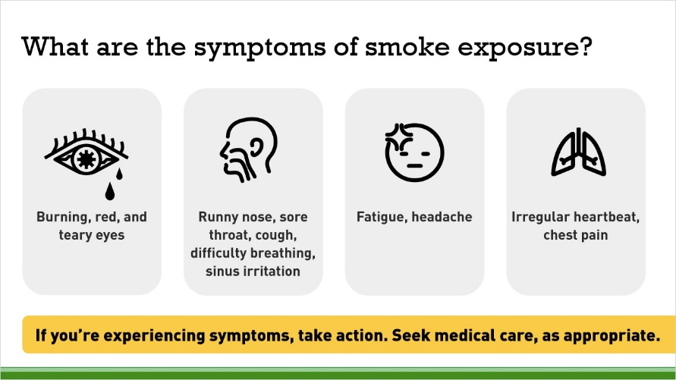

**Notes:**

There are many symptoms common to smoke exposure.   
Watch for the following signs:   
Burning, red, and teary eyes   
Runny nose, sore throat, cough, difficulty breathing, sinus irritation   
Fatigue, headache, irregular heartbeat, chest pain   
Take action and don’t ignore the symptoms. Find a place with safe ventilation and seek medical care, as appropriate.

# 1.9 What actions will SAIF take to protect you from smoke exposure?

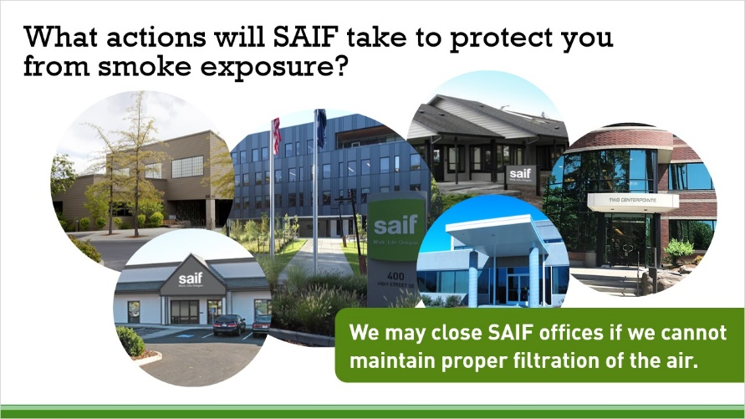

**Notes:**

When wildfires create unhealthy AQI conditions, SAIF's ventilation systems may need to be adjusted.   
During the COVID-19 pandemic, additional levels of air filtration are necessary to keep us safe.   
We may close SAIF offices if we cannot maintain proper filtration of the air.

# 1.10 What actions do I need to take?

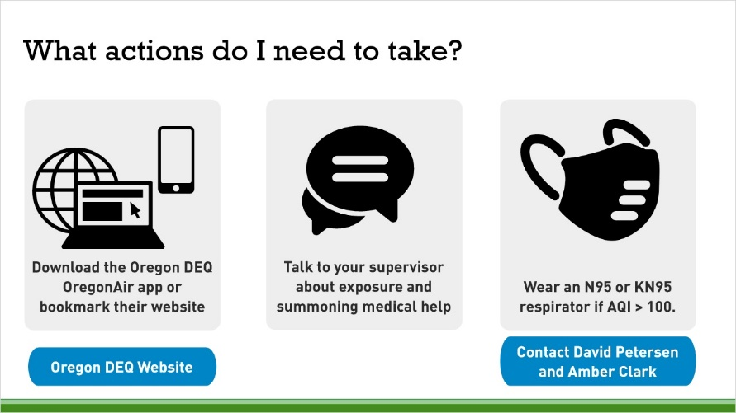

**Notes:**

Talk with your supervisor about limiting your exposure and make sure you can summon medical help if needed.   
Download the DEQ app or bookmark their website. Check it regularly. AQI can also be found on many weather apps. SAIF uses data reported by DEQ to make determinations about risk.   
EPA: AirNow   
Oregon DEQ homepage   
If the AQI is between 100 and 200, please wear a respirator when you are outside. N95 or KN95 respirators are effective for short periods of time. Ensure a proper fit and dispose of your mask when it becomes contaminated or compromised. N95 and KN95 respirators are available for fieldwork by contacting David Petersen and Amber Clark.

# 1.11 How do I put on a respirator?

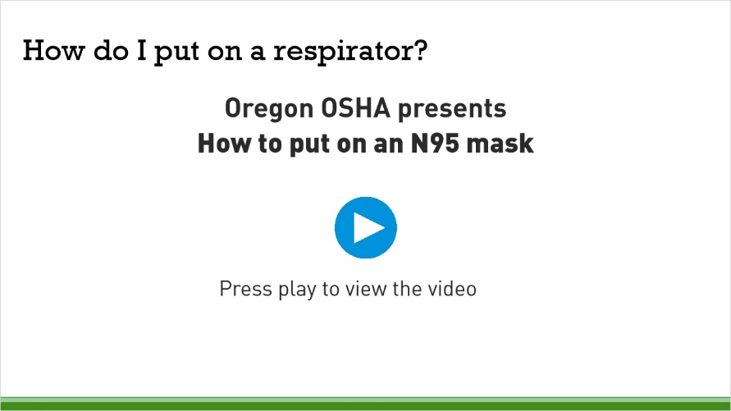

**Notes:**

Press the play button to view a video from Oregon OSHA about How to put on an N95 mask.

# 1.12 Where can I learn more?

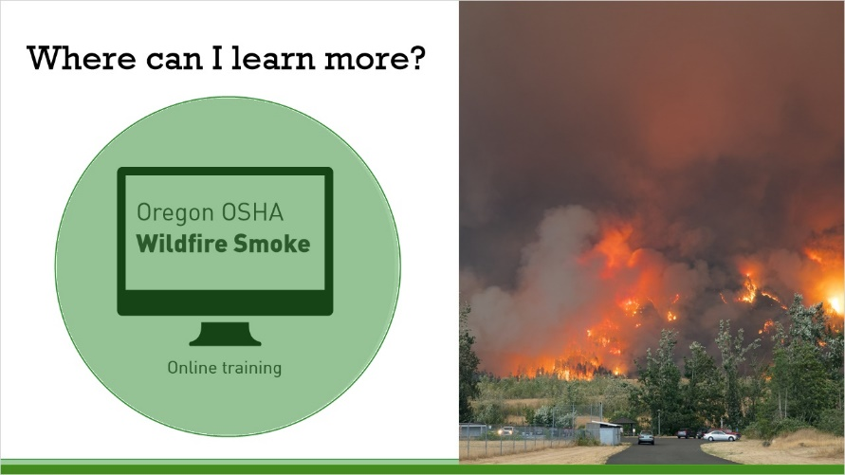

**Notes:**

It is highly recommended that you take the Wildfire Smoke online course created by Oregon OSHA.   
The course covers:   
Symptoms of wildfire smoke exposure   
Health effects of wildfire smoke   
the definition of sensitive groups   
Employee rights   
How to access the Air Quality Index and the pm2.5   
The importance, limitations, and benefits of using a filtering facepiece respirator, and how to properly put them on   
  
Click the link to access the course.   
  
<https://osha.oregon.gov/edu/courses/Pages/wildfire-smoke-online-course.aspx>

# 1.13 Summary

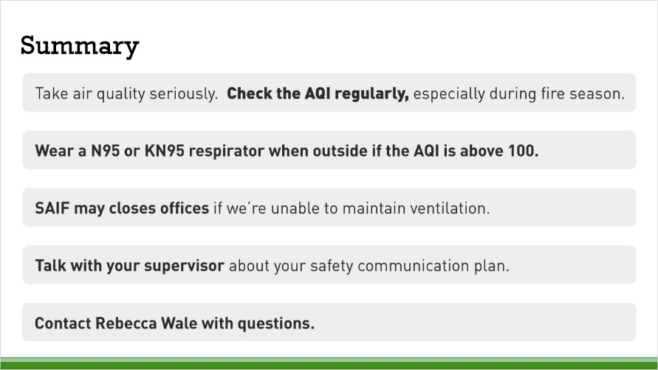

**Notes:**

We all need to take the quality of the air seriously. Check the air quality index regularly, especially during wildfire season, to make decisions based on your personal situation.

As the AQI rises, health risks rise, too. If you work outside and the AQI is above 100, please wear a properly fitted N95 or KN95 while outside.   
  
SAIF may temporarily close offices if we are unable to maintain appropriate ventilation.   
Talk with your supervisor about your safety communication plan.   
If you have any questions, contact Rebecca Wale, SAIF’s Safety Program Manager.

# 1.14 Additional resources

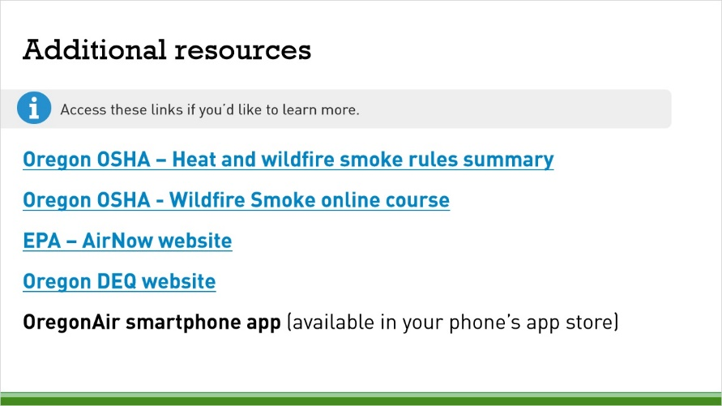

**Notes:**

Access these additional resources to learn more.

Oregon OSHA – Heat and wildfire smoke rules summary  
<https://osha.oregon.gov/OSHARules/adopted/2022/heat-wildfire-smoke-rule-summary-2022.pdfWildfire> Smoke online course – Oregon OSHA   
<https://osha.oregon.gov/edu/courses/Pages/wildfire-smoke-online-course.aspx>   
AirNOW   
<https://gispub.epa.gov/airnow/>   
Oregon DEQ website   
<https://oraqi.deq.state.or.us/home/map>   
OregonAir app

# 1.15 Course complete!



**Notes:**

You’ve completed the module. You may now exit the course.